# Exercise: Objects and Classes

Problems for exercises and homework for the ["Technology Fundamentals" course @ SoftUni](https://softuni.bg/trainings/3448/programming-fundamentals-with-java-september-2021).

You can check your solutions in [Judge.](https://judge.softuni.bg/Contests/1327)

[Видео - 26 юни 2020 - Любомир Томанов - Софтуерен университет (softuni.bg)](https://softuni.bg/trainings/resources/video/50944/video-26-june-2020-lyubomir-tomanov-java-fundamentals-may-2020/2831) may2020

[Java-Fundamentals/src/ObjectAndClasses at master · Kaloyan86/Java-Fundamentals (github.com)](https://github.com/Kaloyan86/Java-Fundamentals/tree/master/src/ObjectAndClasses)

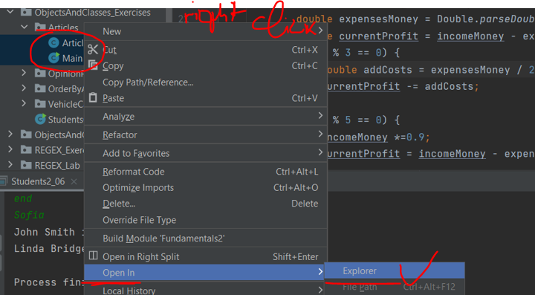

## Advertisement Message

Write a program that **generates random fake advertisement message** to extol some product. The messages must consist of 4 parts: **laudatory** **phrase** + **event** + **author** + **city**. Use the following predefined parts:

* Phrases – {"**Excellent product.**", "**Such a great product.**", "**I always use that product**.", "**Best product of its category.**", "**Exceptional product.**", "**I can’t live without this product.**"}
* Events – {"**Now I feel good.**", "**I have succeeded with this product.**", "**Makes miracles. I am happy of the results!**", "**I cannot believe but now I feel awesome.**", "**Try it yourself, I am very satisfied.**", "**I feel great!**"}
* Authors – {"**Diana**", "**Petya**", "**Stella**", "**Elena**", "**Katya**", "**Iva**", "**Annie**", "**Eva**"}
* Cities – {"**Burgas**", "**Sofia**", "**Plovdiv**", "**Varna**", "**Ruse**"}

The format of the output message is: **{phrase} {event} {author} – {city}**.

As an input, you take the **number of messages** to be generated. Print each random message on a separate line.

### Examples

|  |  |
| --- | --- |
| **Input** | **Output** |
| 3 | Such a great product. Now I feel good. Elena – Ruse  Excelent product. Makes miracles. I am happy of the results! Katya – Varna  Best product of its category. That makes miracles. Eva – Sofia |
| 4 | I always use that product. Makes miracles. I am happy of the results! Iva - Ruse  I can’t live without this product. I cannot believe but now I feel awesome. Katya - Burgas  Such a great product. Try it yourself, I am very satisfied. Iva - Varna  Best product of its category. I cannot believe but now I feel awesome. Eva - Ruse |

## Articles

Create an article class with the following properties:

* **Title** – a string
* **Content** – a string
* **Author** – a string

The class should have a constructor and the following methods:

* **Edit (new content)** – change the old content with the new one
* **ChangeAuthor (new author)** – change the author
* **Rename (new title)** – change the title of the article
* override **ToString** – print the article in the following format:

**"{title} - {content}:{author}"**

Write a program that reads an article in the following format **"{title}, {content}, {author}"**. On the next line, you will get a number **n**. On the next **n lines,** you will get one of the following commands: **"Edit: {new content}"**; **"ChangeAuthor: {new author}"**; **"Rename: {new title}"**. At the end, print the final article.

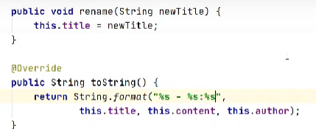

### 

|  |  |
| --- | --- |
| **Input** | **Output** |
| some title, some content, some author  3  Edit: better content  ChangeAuthor: better author  Rename: better title | better title - better content: better author |
| Holy Ghost, content, John Sandford  3  ChangeAuthor: Mitch Albom  ChangeAuthor: better author  ChangeAuthor: Kim Heacox | Holy Ghost - content: Kim Heacox |

## Opinion Poll

Using the Person class, write a program that reads from the console **N** lines of personal information and then prints all people whose **age** is **more than 30** years, **sorted in alphabetical order**.

**Note**: you can use **stream()** to filter people.

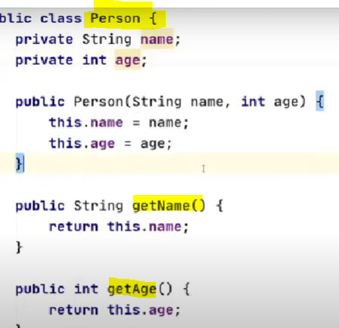

### 

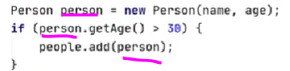

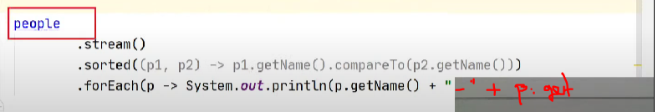

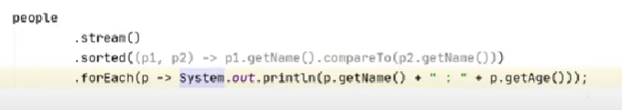

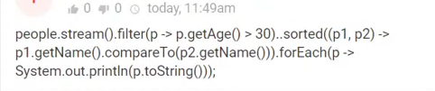

|  |  |
| --- | --- |
| **Input** | **Output** |
| 3  Peter 12  Sam 31  Itan 48 | Itan - 48  Sam – 31 |
| 5  Niko 33  Yana 88  Todor 22  Lisa 44  Sam 11 | Lisa - 44  Niko - 33  Yana – 88 |

## Articles 2.0

Change the program from the second problem, so you can store a **list of articles**. You will not need the methods anymore (**except the ToString method**). On the **first line**, you will get a number **n**. On the **next n lines**, you will get some **articles in the same format** as the previous task (**"{title}, {content}, {author}"**). Finally, you will get **one** of the **three inputs**: **"title", "content", "author"**. You need to **order the articles** ***alphabetically*** based on the command and **print them sorted by the given criteria**.

### 

|  |  |
| --- | --- |
| **Input** | **Output** |
| 2  Science, planets, Bill  Article, content, Johnny  title | Article - content: Johnny  Science - planets: Bill |
| 3  title1, C, author1  title2, B, author2  title3, A, author3  content | title3 – A: author3  title2 – B: author2  title1 – C: author1 |

## Students

Write a program that receives **n count of students** and **orders them by grade** (in **descending**). Each student should have **first name** (string), **last name** (string) and **grade** (floating-point number).

### Input

* First line will be a number **n**
* Next **n** lines you will get a student info in the format **"{first name} {second name} {grade}"**

### Output

* Print each student in the following format **"{first name} {second name}: {grade}"**

### 

|  |  |
| --- | --- |
| **Input** | **Output** |
| 4  Lakia Eason 3.90  Prince Messing 5.49  Akiko Segers 4.85  Rocco Erben 6.00 | Rocco Erben: 6.00  Prince Messing: 5.49  Akiko Segers: 4.85  Lakia Eason: 3.90 |
| 4  Sydnie Britton 5.79  Amias Mathews 2.30  Mora Tod 2.78  Pete Kendrick 2.61 | Sydnie Britton: 5.79  Mora Tod: 2.78  Pete Kendrick: 2.61  Amias Mathews: 2.30 |

## Vehicle Catalogue *

You have to make a catalogue for vehicles. You will receive two types of vehicle - **car** or **truck**.

Until you receive the command "**End**" you will receive **lines** of **input** in the format:

|  |
| --- |
| {typeOfVehicle} {model} {color} {horsepower} |

After the "**End**" command, you will start receiving **models** of **vehicles**. Print for every received vehicle its **data** in the format:

|  |
| --- |
| Type: {typeOfVehicle}  Model: {modelOfVehicle}  Color: {colorOfVehicle}  Horsepower: {horsepowerOfVehicle} |

When you receive the command "**Close the Catalogue**", stop receiving input and print the **average** **horsepower** for the **cars** and for the **trucks** in the format:

"{typeOfVehicles} have average horsepower of {averageHorsepower}."

The **average** **horsepower** is calculated by **dividing** the **sum** of **horsepower** for **all** vehicles of the type by the **total** **count** of **vehicles** from the **same** **type**.

Format the answer to the **2nd decimal point**.

### Constraints

* The type of vehicle will always be **car** or **truck**
* You will not receive the **same** **model** **twice**
* The received horsepower will be integer in the interval **[1…1000]**
* You will receive at most **50** vehicles
* **Single** whitespace will be used for **separator**

### 

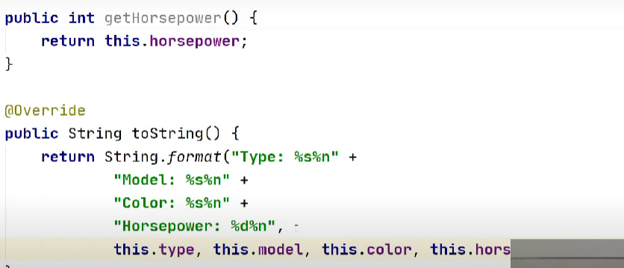 ***Do same for Class CAR***



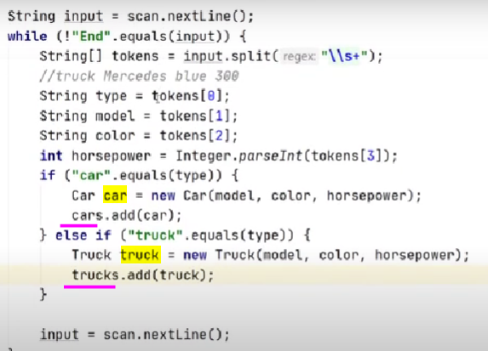

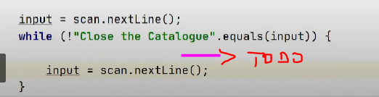

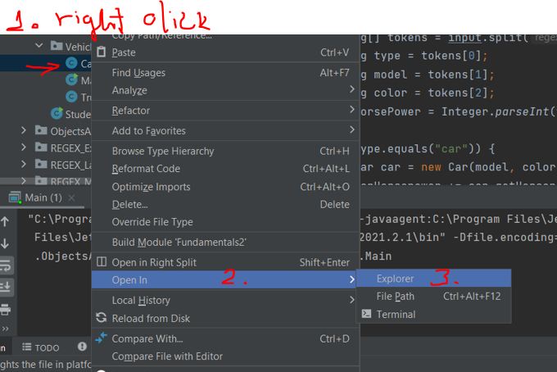

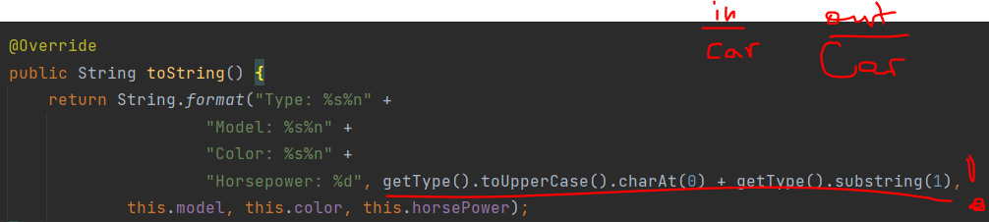

|  |  |
| --- | --- |
| **Input** | **Output** |
| truck Man red 200  truck Mercedes blue 300  car Ford green 120  car Ferrari red 550  car Lamborghini orange 570  End  Ferrari  Ford  Man  Close the Catalogue | Type: Car  Model: Ferrari  Color: red  Horsepower: 550  Type: Car  Model: Ford  Color: green  Horsepower: 120  Type: Truck  Model: Man  Color: red  Horsepower: 200  Cars have average horsepower of: 413.33.  Trucks have average horsepower of: 250.00. |
| car Opel green 736  End  Close the Catalogue | Cars have average horsepower of: 736.00.  Trucks have average horsepower of: 0.00. |

## Order by Age

You will receive an **unknown** number of lines. On each line, you will receive an array with **3** elements. **The first** element will be **string** and represents the **name** of the person. **The second** element will be a **string** and will represent the **ID** of the person. **The last** element will be an **integer** which represents the **age** of the person.

When you receive the command "**End**", stop taking input and print **all the** **people**, **ordered** by **age**.

### Examples

|  |  |
| --- | --- |
| **Input** | **Output** |
| George 123456 20  Peter 78911 15  Stephan 524244 10  End | Stephan with ID: 524244 is 10 years old.  Peter with ID: 78911 is 15 years old.  George with ID: 123456 is 20 years old. |
| Cindy 88611 2  Kaloyan 13967 3  Simona 53316 11  Gil 31837 72  End | Cindy with ID: 88611 is 2 years old.  Kaloyan with ID: 13967 is 3 years old.  Simona with ID: 53316 is 11 years old.  Gil with ID: 31837 is 72 years old. |